FTPS R1

Design Documentation  
Prepared by Team 1:

* Mitchell Derby
* Pedro Vega
* Beltran Caliz
* Quang Vu

**Table of Contents**

Summary 2

Requirements 3

Domain Model 4

System Architecture 5

Subsystems 6

Subsystem #1 6

Subsystem #2 6

Appendix 7

# Summary

This section provides a brief overview of the project.

* Describe your high-level architectural, i.e. subsystem, design.
* Give a rationale for the major design choices
* Tie back to specific requirements statements
* Outline how the design reflects a balance among competing design principles such as low coupling and etc

# Requirements

This section provides an enumeration of the project’s requirements.

|  |  |
| --- | --- |
| **R#** | **Requirement** |
| 1 | System Tracks multiple Portfolios |
| 1A | System allows users to create a portfolio |
| 1B | System persists holdings and transactions in a portfolio across invocations of the system |
| 1C | System allows users to import holdings and transactions when creating a new portfolio |
| 2 | System requires users to log in before granting access to the portfolio |
| 2A | System starts up and requests a login-id and password |
| 2B | System provides a mechanism for creating a new portfolio |
| 3 | System maintains the holdings in a portfolio, with multiple holdings. |
| 3A | System allows users to add holdings to a portfolio |
| 3B | System allows users to remove stocks, bonds, mutual funds, etc. from a portfolio |
| 3C | System allows users to import holdings and transactions |
| 3D | System allows the user to make cash deposits and withdrawals from money and reflect it in the portfolio |
| 3E | System allows users to make transfers between money market account or bank account |
| 4 | System maintains information about equities (including ticker symbol, name, etc.) that can be added by the user. |
| 5 | System allows users to search |
| 5A | Users are able to search for ticker symbol, equity name, or index |
| 5B | Users are able to search for a term |
| 5C | Users are able to refine a search by specifying more than one field |
| 5D | The system displays the ticker symbol that matches the search and allows users to select one entry and populate the ticker input field. |
| 6 | System displays the portfolio’s information |
| 6A | Users are able to view all holdings in a portfolio |
| 6B | System has a history of portfolio transactions |
| 7 | System allows users to specify a time period and market simulation algorithm to use |
| 7A | System allows users to specify the number of steps to move forward and a time interval for each step. |
| 7B | Users can select a no-growth-market simulation algorithm |
| 7C | Users can select a bull -market simulation algorithm |
| 7D | Users can select a bear-market simulation algorithm |
| 7E | At the end of a simulation, system displays the portfolio value and allows user to run another simulation from this point or reset the stock prices |
| 8 | System allows users to save the portfolio |
| 8A | System saves portfolios for use across all invocations |
| 8B | System allows users to export portfolio holdings and transactions for import to another portfolio |
| 9 | System allows users to logout |
| 9A | System provides and option to save changes if there are unsaved changes when loging out |
| 9B | System requests login-id and password after exiting |

# Domain Model

This section provides a domain model for the project. It should follow the guidelines discussed in class and the design project activity sheets.

# 

# System Architecture

This section provides a model of the subsystem components that make up the overall software architecture for the project. Draw the subsystems as simple boxes with relationships between them. Provide a narrative that describes the responsibilities of each component and the interfaces that are provided between subsystems.

# 

# Subsystems

This section provides detailed design for specific subsystems described in the system architecture.

## Subsystem #1 (name the subsystem with a name that expresses its use within the context of the application)

This section provides a description and UML class structure diagrams that model subsystem #1. You should also describe dynamic behaviors that are primarily located within this subsystem using sequence diagrams and a narrative to explain the behavior.

For each design pattern that you are using within this subsystem complete a design pattern usage table. If a design pattern cuts across the boundary of subsystems, place the pattern usage table in the section for the subsystem that holds the majority of pattern participants.

|  |  |
| --- | --- |
| **Generic GoF Design Pattern:** | Strategy |
| **System Context Pattern:** | System Algorithms / Market simulation algorithm |
| **Participants:** |  |
| * Client | * User |
| * Context | * Portfolio/Button |
| * Strategy | * Market simulation algorithm |
| * ConcreteStrategy1 | * No growth-market simulation algorithm |
| * ConcreteStrategy2 | * Bull-market simulation algorithm |
| * ConcreteStrategy3 | * Bear-market simulation algorithm |
| **Requirements Covered:** | R7 |

|  |  |
| --- | --- |
| **Generic GoF Design Pattern:** | Observer |
| **System Context Pattern:** | System Menu Bar |
| **Participants:** |  |
| * Subject/Observable | * Portfolio |
| * Observer | * Buttons |
| * ConcreteObserver | * Logout Button |
| * ConcreteObserver | * Save Button |
| * ConcreteObserver | * Open Button |
| **Requirements Covered:** | R8, R9 |

## Subsystem #2

This section provides a similar description and diagrams the model describing subsystem #2.

# Sequence Diagrams

This section contains the sequence diagrams and narrative text that describe the operation of major features in the application. At a minimum, you should document any features that are listed in the design project problem statement. You may also decide that other features require documentation.

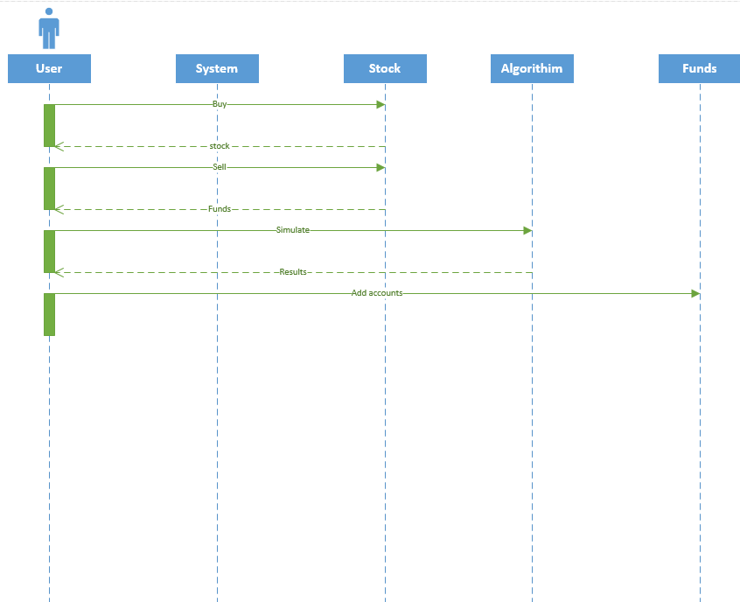

# Appendix

This section provides fine-grained design details for all of the classes in your design. You will capture this information using the CRC (Class-Responsibilities-Collaborators) card format below.

|  |  |
| --- | --- |
| **Class:** Account |  |
| **Responsibilities:** ... |  |
| **Collaborators:** ... |  |
| **Users:** ... | **Used by:** ... |
| **Author:** ... |  |

|  |  |
| --- | --- |
| **Class:** Algorithm |  |
| **Responsibilities:** ... |  |
| **Collaborators:** ... |  |
| **Users:** ... | **Used by:** ... |
| **Author:** ... |  |

|  |  |
| --- | --- |
| **Class:** BearMarket |  |
| **Responsibilities:** ... |  |
| **Collaborators:** ... |  |
| **Users:** ... | **Used by:** ... |
| **Author:** ... |  |

|  |  |
| --- | --- |
| **Class:** BullMarket |  |
| **Responsibilities:** ... |  |
| **Collaborators:** ... |  |
| **Users:** ... | **Used by:** ... |
| **Author:** ... |  |

|  |  |
| --- | --- |
| **Class:** EquitiesHolder |  |
| **Responsibilities:** ... |  |
| **Collaborators:** ... |  |
| **Users:** ... | **Used by:** ... |
| **Author:** ... |  |

|  |  |
| --- | --- |
| **Class:** EquityParser |  |
| **Responsibilities:** ... |  |
| **Collaborators:** ... |  |
| **Users:** ... | **Used by:** ... |
| **Author:** ... |  |

|  |  |
| --- | --- |
| **Class:** GViewControl |  |
| **Responsibilities:** ... |  |
| **Collaborators:** ... |  |
| **Users:** ... | **Used by:** ... |
| **Author:** ... |  |

|  |  |
| --- | --- |
| **Class:** Holding |  |
| **Responsibilities:** ... |  |
| **Collaborators:** ... |  |
| **Users:** ... | **Used by:** ... |
| **Author:** ... |  |

|  |  |
| --- | --- |
| **Class:** NoGrowthMarket |  |
| **Responsibilities:** ... |  |
| **Collaborators:** ... |  |
| **Users:** ... | **Used by:** ... |
| **Author:** ... |  |

|  |  |
| --- | --- |
| **Class:** Portfolio |  |
| **Responsibilities:** ... |  |
| **Collaborators:** ... |  |
| **Users:** ... | **Used by:** ... |
| **Author:** ... |  |

|  |  |
| --- | --- |
| **Class:** PortfolioController |  |
| **Responsibilities:** ... |  |
| **Collaborators:** ... |  |
| **Users:** ... | **Used by:** ... |
| **Author:** ... |  |

|  |  |
| --- | --- |
| **Class:** PortfolioParser |  |
| **Responsibilities:** ... |  |
| **Collaborators:** ... |  |
| **Users:** ... | **Used by:** ... |
| **Author:** ... |  |

|  |  |
| --- | --- |
| **Class:** Transaction |  |
| **Responsibilities:** ... |  |
| **Collaborators:** ... |  |
| **Users:** ... | **Used by:** ... |
| **Author:** ... |  |

|  |  |
| --- | --- |
| **Class:** User |  |
| **Responsibilities:** ... |  |
| **Collaborators:** ... |  |
| **Users:** ... | **Used by:** ... |
| **Author:** ... |  |

|  |  |
| --- | --- |
| **Class:** UserParser |  |
| **Responsibilities:** ... |  |
| **Collaborators:** ... |  |
| **Users:** ... | **Used by:** ... |
| **Author:** ... |  |

# Discussion

A discussion of the state of your implementation and any known issues with it.